# CSS: A brief non-technical overview

## What is CSS?

CSS is an abbreviation of Cascading Style Sheets, a style sheet language for markup (XML, HTML, XHTML). It empowers developers to separate document content from presentation.

Style sheets are collections of stylistic rules; they have been used by editors and typographers since long before the web. A style sheet language describes the presentation of structured documents, like an HTML document. CSS is 'Cascading' because multiple files can be combined to style one page.

## A Brief History of CSS

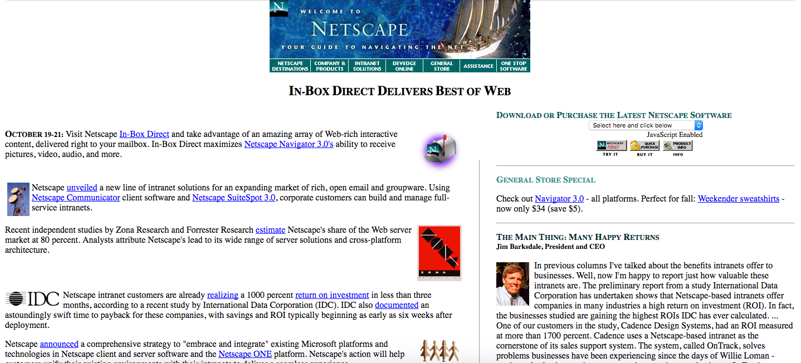Netscape October 20, 1996

* Early 1990's: HTML popularity was increasing and developers were frustrated with its limited styling abilities.
* October 1994: Hakon Wium Lie released the first draft of “Cascading HTML Style Sheets”
* August 1996: Microsoft Internet Explorer became the first browser to support CSS
* December 1996: CSS 1 release
  + Included: font properties, text attributes, alignment of text, tables, images, colors of text and backgrounds, spacing of words, letters and lines, margins, borders, padding and positioning, unique identification and classification of groups of attributes.
* Early 1997: The W3C formed the [CSS and Formatting Properties Working Group](https://en.wikipedia.org/wiki/CSS_Working_Group) to focus solely on CSS standards. (Browsers used to display styling much less consistently)
* 1998: CSS 2 release
  + Added: z-index, media types, bidirectional text, absolute, relative and fixed positioning
* June 2011 and June 2012: CSS 3 capabilities were separated into modules.
  + Four new modules were added: color, selectors level 3, namespaces, media queries

## Adding Style to HTML: Inline, Internal, and External CSS

There are three ways a developer may add style to an HTML document. External CSS is most often preferred, but you will undoubtedly encounter inline and internal styles in the wild. They are discussed in order of specificity: inline > internal > external

### Inline Style Attribute

Exactly what the title suggests: style attributes added directly on an HTML element inside of the element's opening HTML tag.

<h2 style="color: #000000; font-size: 2em;"> Hi </h2>

Pros:

* Highest specificity: Ensures the style will be applied to the element

Cons:

* Highest specificity: will overwrite most other styles in an internal or external sheet
* Redundant; not DRY
* Cluttered, unreadable HTML markup
* Difficult to manage
* Impossible to style pseudo-elements and classes like visited, hover, and active

Extra note: When you change an element's style using Javascript, it affects the element's inline style and can overwrite existing inline styles permanently.

### Internal: Embedded style tag

Styles for many elements are collected between <style> tags in the <head> section of an HTML document. This is referred to as an internal style sheet or embedded style tag because it is a complete stylesheet embedded inside of an HTML document.

<head>

<style type="text/css">

h2 {

color: #000000;

font-size: 2em;

}

h3 {

color: #FF69B4;

font-size: 1em;

}

</style>

</head>

Pros:

* Cleaner HTML markup than inline styles: all styles are in one section of the document
* Selectors apply styles to multiple elements on a page
  + Smaller page size than using all inline styles
  + More DRY than inline styles
* Apply styles to the document they are embedded within; not globally

Cons:

* Loaded with the HTML page and not cached by the browser

### External file: linked stylesheet

An external stylesheet is a simply a file dedicated to CSS, that must be linked in the <head> of an HTML document. This is the way we will do most of our styling.

<link rel="stylesheet" type="text/css" href="styles.css" />

Pros:

* Can be cached by browsers for improved performance
* Global: can be used across pages in your site

Cons:

* Global: the developer must structure the CSS so that styles are not applied to elements they are not intended for.

## Some terms related to CSS in industry

* UI: Short for user interface, or how a user interacts with a device or technology. CSS helps a UI design communicate how a user might use a web app. If you see a job posting for a UI Developer, that role likely includes writing a lot of HTML and CSS. Ex: "The Windows 10 UI is so confusing! I don't know how to change any settings."
* Responsive: A web design is responsive if it adjusts to (and looks decent across) different device screen sizes. Ex: "My orthodontist's website looks okay on my laptop, but it isn't responsive. It displays weirdly on mobile and I can't find her contact information."
  + Breakpoints: Set in a web page's styles, breakpoints are the markers at which a change will occur to improve the UI. Ex: "Please add a breakpoint so the picture grid on this page has four columns on wide screens and three columns on screens less than 1024px wide."
    - Example: When a container element is <= 480px wide, its inner elements will stack in one column instead of two columns.
  + Media queries: Used for device-specific breakpoints. They include an optional media type and expressions that limit the scope of their contained styles. Ex: "The app's styles include media queries for smartphone and tablet screens."
    - Example:
    - @media only screen
    - and (min-device-width: 320px)
    - and (max-device-width: 480px){
    - font-size: 12px;

}

* Pixel perfect: Replicating a mockup perfectly (down to the pixel level). Sometimes used to mean great attention to detail. Ex: "The design team gave me a mockup annotated with specifications so that my implementation can be pixel-perfect."
  + Flat design: A minimalist UI design language characterized by simple elements, subtle typography, and flat colors. Ex: "You should make your app responsive and use flat design for a more modern look."
  + Skeuomorphism: A design language characterized by elements that look like their counterparts in the real world. Ex: "Remember iOS6 when the icons looked really bulgy and realistic? I miss skeuomorphism."
  + Grid system: A simple type of CSS framework that provides column systems for grid layouts, usually helpful for responsive designs Ex: "Use a grid system to ensure all the photos in your photo album app are evenly spaced."
* [W3C](https://www.w3.org/): The group responsible for HTML and CSS standards. It is the largest standards body for Internet design and best practices. Ex: "My lifelong dream has been to join the W3C and fight browser inconsistencies!"